Use Case Diagram: Reception/Specimen Collector

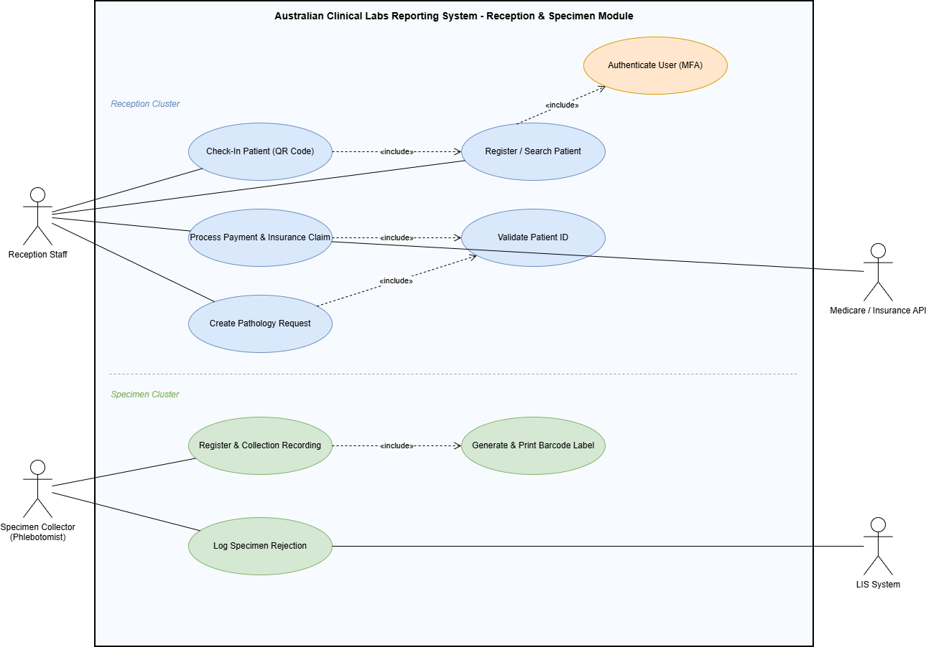

Use Case Traceability Matrix
Use Case Name | Primary Actor | Secondary Actor / System | Mapped FR No.
Check-In Patient (QR Code) | Reception Staff | — | FR50
Register / Search Patient | Reception Staff | — | FR7, FR9
Authenticate User (MFA) | Reception Staff / Staff | — | FR2, FR3
Process Payment & Insurance Claim | Reception Staff | Medicare / Insurance API | FR52, FR54
Create Pathology Request | Reception Staff | — | FR12, FR13
Validate Patient ID | Reception Staff | — | FR8
Register & Collection Recording | Specimen Collector | — | FR17, FR20

